#include <windows.h>
#include <shlobj.h>
#include <iostream>
#include <fstream>
#include <string>
#include <ctime>
#include <sstream>
using namespace std;

void setConsoleColor(const string& color) {
if (color == "red") {
system("color 4");
}
else if (color == "blue") {
system("color 1");
}
else if (color == "green") {
system("color 2");
}
else if (color == "yellow") {
system("color 6");
}
else if (color == "white") {
system("color 7");
}
else if (color == "black") {
system("color 0");
}
else {
system("color 0");
}
}

string getCurrentTime() {
time_t now = time(0);
char buffer[26];
ctime_s(buffer, sizeof(buffer), &now);
string timeStr(buffer);
timeStr.pop_back();
return timeStr;
}

string getDesktopPath() {
char path[MAX_PATH];
if (SHGetFolderPathA(NULL, CSIDL_DESKTOPDIRECTORY, NULL, 0, path) == S_OK) {
return string(path) + "\\";
}
return "";
}

bool loadSettings(string& color, string& city, string& lastChangeTime) {
string settingsPath = getDesktopPath() + "settings.txt";
ifstream fin(settingsPath);

if (!fin.is_open()) {
return false;
}

if (fin.peek() == EOF) {
fin.close();
return false;
}

string line, lastLine;
while (getline(fin, line)) {
if (!line.empty()) {
lastLine = line;
}
}
fin.close();

if (lastLine.empty()) {
return false;
}

size_t firstSpace = lastLine.find(' ');
if (firstSpace == string::npos) {
return false;
}

color = lastLine.substr(0, firstSpace);

size_t secondSpace = lastLine.find(' ', firstSpace + 1);
if (secondSpace == string::npos) {
city = lastLine.substr(firstSpace + 1);
lastChangeTime = "";
}
else {
city = lastLine.substr(firstSpace + 1, secondSpace - firstSpace - 1);
lastChangeTime = lastLine.substr(secondSpace + 1);
}

return true;
}

void saveSettings(const string& color, const string& city) {
string settingsPath = getDesktopPath() + "settings.txt";
string timeStr = getCurrentTime();

ofstream fout(settingsPath, ios::app);

if (fout.is_open()) {
fout << color << " " << city << " " << timeStr << endl;
fout.close();
cout << "Настройки сохранены!" << endl;
}
else {
cout << "Ошибка сохранения!" << endl;
}
}

void showCurrentSettings(const string& color, const string& city, const string& timeStr = "") {
cout << "\nТекущие настройки:" << endl;
cout << "Цвет текста: " << color << endl;
cout << "Любимый город: " << city << endl;
if (!timeStr.empty()) {
cout << "Последнее изменение: " << timeStr << endl;
}
}

void changeSettings(string& color, string& city) {
cout << "\nВведите цвет текста (red, blue, green, yellow, white, black): ";
cin >> color;
cout << "Введите любимый город: ";
cin.ignore();
getline(cin, city);

saveSettings(color, city);
}

int main() {
setlocale(0, "");

string color = "white";
string city = "Москва";
string lastChangeTime;

string settingsPath = getDesktopPath() + "settings.txt";

if (loadSettings(color, city, lastChangeTime)) {
setConsoleColor(color);

showCurrentSettings(color, city, lastChangeTime);

char choice;
cout << "\nИзменить настройки? (y/n): ";
cin >> choice;

if (choice == 'y' || choice == 'Y') {
changeSettings(color, city);

setConsoleColor(color);

loadSettings(color, city, lastChangeTime);
showCurrentSettings(color, city, lastChangeTime);
}
}
else {
cout << "Настроек нет. Введите новые:\n";
cout << "Введите цвет текста (red, blue, green, yellow, white, black): ";
cin >> color;
cout << "Введите любимый город: ";
cin.ignore();
getline(cin, city);

saveSettings(color, city);

setConsoleColor(color);

showCurrentSettings(color, city, getCurrentTime());
}

while (true) {
cout << "\n=== Меню ===" << endl;
cout << "1. Изменить настройки" << endl;
cout << "2. Показать настройки" << endl;
cout << "3. Применить цвет" << endl;
cout << "4. Выйти" << endl;
cout << "Выберите: ";

int menuChoice;
cin >> menuChoice;

switch (menuChoice) {
case 1:
changeSettings(color, city);
loadSettings(color, city, lastChangeTime);
break;
case 2:
showCurrentSettings(color, city, lastChangeTime);
break;
case 3:
setConsoleColor(color);
cout << "Цвет применен!" << endl;
break;
case 4:
cout << "Выход..." << endl;
return 0;
default:
cout << "Неверный выбор!" << endl;
break;
}
}

return 0;
}
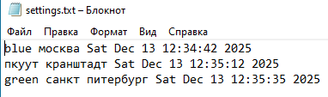
Рисунок 1

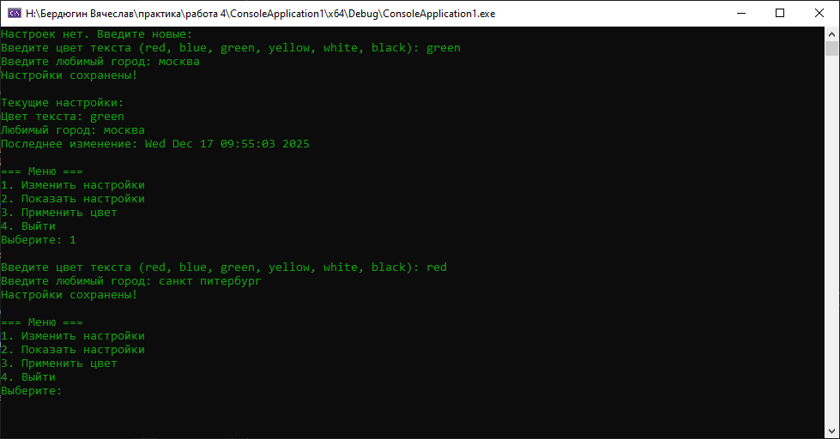
Рисунок 2

